____________________________________________________________________________

Status of code / additional notes
Points / descriptions to check
Priority to check
Choice (to re-visit later or after writing code in full)
Checks
Code snippets

____________________________________________________________________________

Text file with information about Deltas (COMPLETE)

Table of:
Delta, Mc_SLN, Mp_SLN, sigma_LN, sigma_SLN, alpha_SLN, alpha_CC3, beta

Isatis runs

Unmodified version
- Monochromatic MF

____________________________________________________________________________

START OF PROGRAM:

Imports:
- numpy
- matplotlib.pyplot
- matplotlib

Plotting style code

___________________________________________________________________________
OUTLINE:
- Methods:
  - To evolve phi (or psi, if possible)
    - Check: for log-normal, Fig. 2 of MP ‘22
  - To calculate psi(M, t) [if necessary]
  - alpha_eff_extracted(M_init): Result for alpha_eff, extracted from Fig. 1 of Mosbech & Picker (2022).
  - mass_evolved(M_init_values, t): Find the PBH mass at time t, evolved from initial masses M_init_values.
  - constraint_Carr(): Calculate constraint on f_PBH for an extended mass function, using the method from 1705.05567.

____________________________________________________________________________

METHODS:

constraint_Carr(mc_values, m_delta, f_max, psi_initial, params, t):
"""
Calculate constraint on f_PBH for an extended mass function, using the method from 1705.05567.

Parameters
----------
mc_values : Array-like
Characteristic PBH masses (m_c for a (skew-)lognormal, m_p for CC3).
m_delta : Array-like
Masses at which constraints for a delta-function PBH mass function are evaluated..
f_max : Array-like
Constraints obtained for a monochromatic mass function.
psi_initial : Function
Initial PBH mass function (in terms of the mass density).
params : Array-like
Parameters of the PBH mass function.
evolved : Boolean
If True, calculate constraints using the evolved PBH mass function.
t : Float
Time (after PBH formation) at which to evaluate PBH masses.
Returns
-------
f_pbh : Array-like
Constraints on f_PBH.

"""

If the constraints are only calculated at PBH masses greater than 1e18g, ignore the effect of evaporation:
if min(m_delta) > 1e18:
evolved = False

f_pbh = []

m_init_values_input = np.concatenate((np.arange(m_star, m_star*(1+1e-11), 5e2), np.arange(m_star*(1+1e-11), m_star*(1+1e-6), 1e7), np.logspace(np.log10(m_star*(1+1e-4)), 18, 500)))
m_values_input = mass_evolved(m_init_values_input, t)

for m_c in mc_values:

if evolved:

- Find the evolved mass function at time t after PBH formation
psi_initial_values = psi_initial(m_init_values_input, m_c, *params)
psi_evolved_values = psi_evolved_normalised(psi_initial_values, m_values_input, m_init_values_input)

- Interpolate the evolved mass function at the masses that the delta-function mass function constraint is calculated at
m_values_input_nozeros = m_values_input_nozeros[psi_evolved_values > 0]
psi_evolved_values_nozeros = psi_evolved_values[ psi_evolved_values > 0]
psi_evolved_interp = 10**np.interp(np.log10(m_delta), np.log10(m_values_input_nozeros), np.log10(psi_evolved_values_nozeros), left=-100, right=100)

integral = np.trapz(psi_evolved_interp / f_max, m_delta)
if integral == 0 or np.isnan(integral):
f_pbh.append(10)
else:
f_pbh.append(1/integral)

else:
integral = np.trapz(psi_initial(m_delta, m_c, *params) / f_max, m_delta)
if integral == 0 or np.isnan(integral):
f_pbh.append(10)
else:
f_pbh.append(1/integral)
return np.array(f_pbh)

Tests

For evolved MFs, in MP22_Fig4_reproduction_minimal.py

See final cell
- Test of method constraints_Carr() [constraint_evolved in the previous cell and constraint_evolved_CC should match exactly].
- Uses the Fermi-LAT data from Lacroix et al. (2015), monochromatic MF constraint calculated using CL=0 in isatis_reproduction.py

Compare results for unevolved MFs, for other constraints

511 keV line constraints (Korwar & Profumo (2023))

Galactic photon constraints (Korwar & Profumo (2023))

Side tests / extra checks

Practicalities of using normalised and non-normalised extended MF calculation

Korwar & Profumo (2023)

When calculating the normalised MF, the results are divided by an integral of the mass function over the mass. This means that the amplitude of the normalised MF is sensitive to the mass range used for integration. If the mass range is too small, then the amplitude of the normalised MF is too large.

In the method constraint_Carr(), by default I am calculating the normalised MF using the mass range at which the delta-function MF constraint is calculated.

The maximum mass at which the delta-function MF constraint is estimated is at ~3e17g.

To compare the accuracy of the normalised MF to the unnormalised MF:
- Compare the evolved mass functions to the initial mass functions at masses where the effects of evaporation are negligible (M >~ 1e15g).

In practice, I find that for M_c >~ 1e16g, with a maximum value of M = 3e17g, the prediction of the unnormalised MF is considerably better than that of the normalised MF (for Delta = 5, with M_p = 1e17g, the difference from the initial mass can be a factor of 10 at M>3e15g!) [shown in figure below]
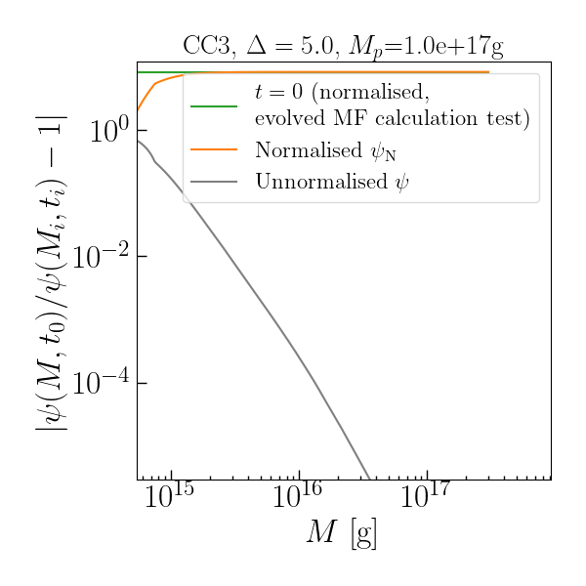

Ways to address this:
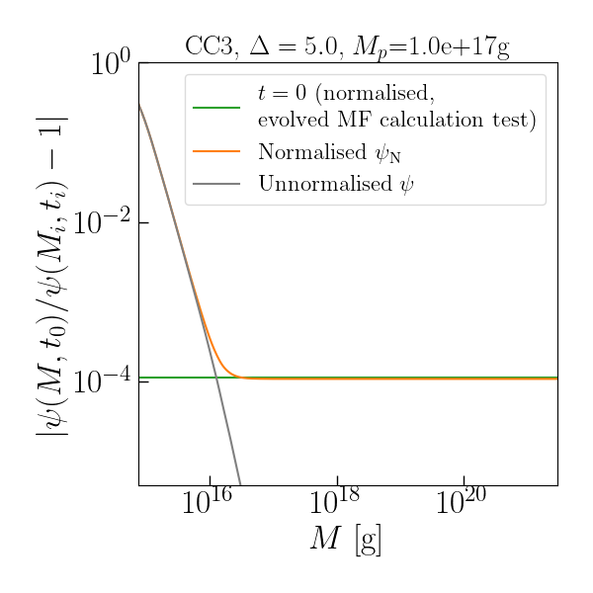
- Use the normalised MF, but calculate the normalisation integral over a wider range of masses (e.g. for a maximum mass M=1e21g, the fractional difference approaches ~3e-4 at M > 3e15g for the CC3 with Delta=5.0 and M_p = 1e17g) [done]
- + Closer to “correct”, from what I understand of the method from Carr et al. (2017)
- - Slightly more complicated to calculate

- Use the unnormalised MF
  - + Simpler, requires no additional calculations
  - - I don’t think it is exactly correct [decided against this]

Changes:
Modify the following code line in constraints_Carr():

m_init_values_input = np.concatenate((np.arange(m_star, m_star*(1+1e-11), 5e2), np.arange(m_star*(1+1e-11), m_star*(1+1e-6), 1e7), np.logspace(np.log10(m_star*(1+1e-4)), np.log10(max(m_delta)), 500)))

to

m_init_values_input = np.concatenate((np.arange(m_star, m_star*(1+1e-11), 5e2), np.arange(m_star*(1+1e-11), m_star*(1+1e-6), 1e7), np.logspace(np.log10(m_star*(1+1e-4)), np.log10(max(m_delta))+4, 500)))

Number of steps to evaluate MF at
- So far, have been evaluating the evolved MF at 500 masses for interpolation and calculating the extended MFs
- Compare agreement with initial MF at M >~ 1e15g using: 500, 1000, 5000 steps, with the maximum mass M_max = 3e21g

500 steps

1000 steps

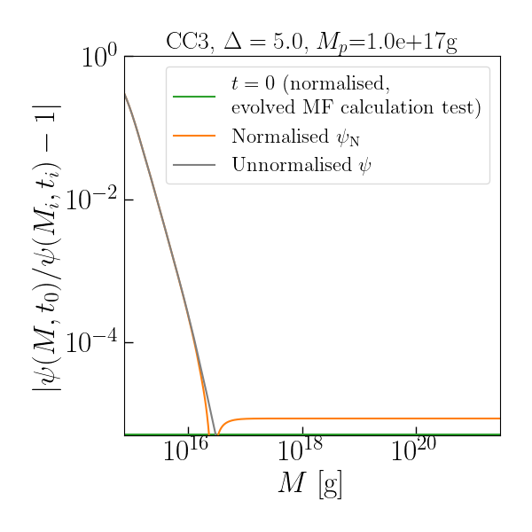

5000 steps

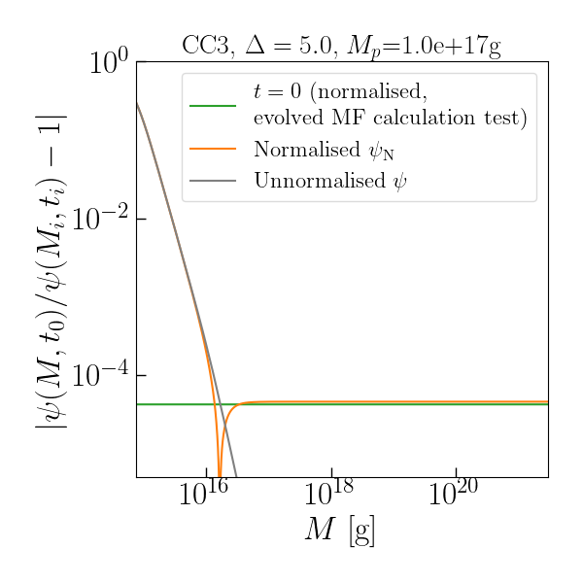

Results:
- The difference is small (sub-percent) for all numbers of steps I tried (varying the number of steps by an order of magnitude varies the fractional difference by a factor of ~2) => the mass range is much more significant than the number of steps used
- The absolute value of the difference is minimised using 1000 steps => use 1000 steps

Check effects on MP22_Fig4_reproduction_minimal.py results
- Changing from 500 to 1000 steps (to 5000 steps) has a sub-percent effect on the results for M_c >~ 4e15g (for a mass range up to 1e22 g in the calculation)
  - At smaller M_c, the difference can reach up to 65%, and becomes consistently worse as M_c decreases
- Changing the upper limit of the mass range from 1e18g to 1e22g (using 1000 steps) leads to a sub-percent difference for M_c >~ 5e15g
  - At smaller M_c, the difference can reach up to 60%, and becomes consistently worse as M_c decreases

It appears unlikely that these changes will have a significant effect on the results in the mass range that I am interested in.

Check of method constraint_Carr() when reproducing constraints
Compare results obtained with the unevolved MF constraints

In the following plots:
- Solid line: the “old” calculations that I calculated with the old version of the method constraint_Carr()
- “x”: Calculated using the new version of the method constraint_Carr(), with the argument evolved=False
- “+”: Calculated using the new version of the method constraint_Carr(), with the argument evolved=True and t=0

Korwar & Profumo (2023)

Delta = 0.0: difference between solid line, “x” and “+” is < 1% at all peak masses m_p plotted that I’ve checked
Delta = 5.0: difference between solid line and “+” is very small, while the difference between the solid line and “x” is approximately 10% for all three mass functions at M_c <~ a few times 10^16 g, and is visible upon zooming in

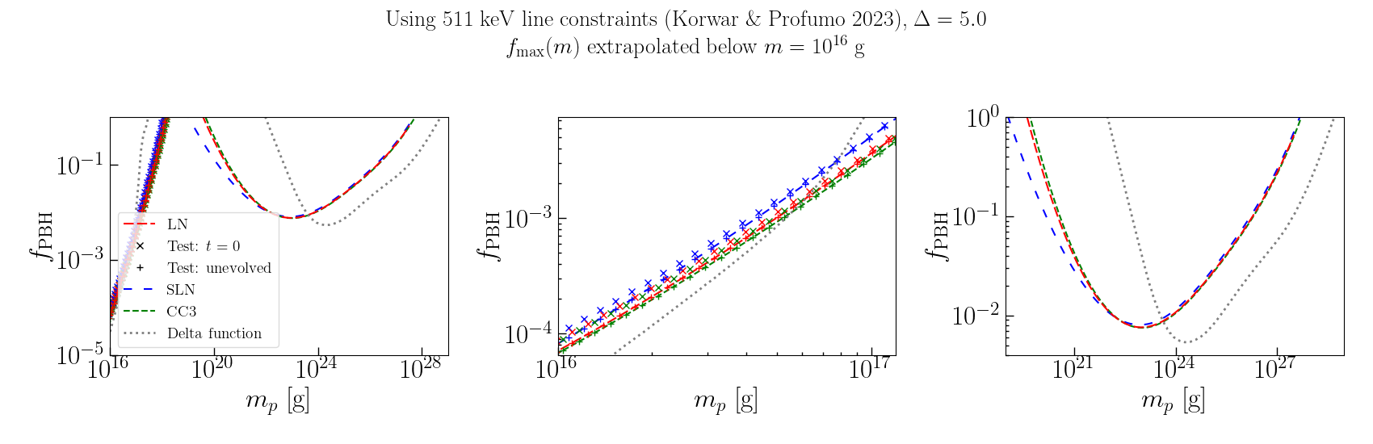
To understand:
How does a sub-percent (< 1e-4) difference in the mass function lead to a ~10% difference in the results for f_PBH at small M_c?

Possibility:
- Currently, the minimum and maximum masses I am calculating the masses at are ~7e14g and ~3e21g
  - For M_c close to 1e16g, this includes considerably more of the mass function at higher masses than at lower masses [for the LN and SLN, M_c > M_p, so the lower range of masses below M_c should be wider (in log space) than the range above (in log space)
  - It may be that including a wider range at lower masses would bring the results into closer agreement. For the evolved MF this would be less of a problem, since the minimum masses close to ~7e14g will be “stretched” due to evaporation into a wider range of PBH masses at late times

To check:
- Change the following line of code in the method constraints_Carr() in preliminaries.py

m_pbh_values_formation = np.concatenate((np.arange(m_star, m_star*(1+1e-11), 5e2), np.arange(m_star*(1+1e-11), m_star*(1+1e-6), 1e7), np.logspace(np.log10(m_star*(1+1e-4)), np.log10(m_delta_max_KP23)+4, 1000)))

to

m_init_values_input = np.sort(np.concatenate((np.logspace(np.log10(min(m_delta)), np.log10(m_star), 1000), np.arange(m_star, m_star*(1+1e-11), 5e2), np.arange(m_star*(1+1e-11), m_star*(1+1e-6), 1e7), np.logspace(np.log10(m_star*(1+1e-4)), np.log10(max(m_delta))+4, 1000))))

Results:
- “x” (setting t=0 in the calculation) agrees with “+” and solid line, even at M_c ~ 1e16g

Comment:
This change is likely to be unhelpful or irrelevant when actually evolving the mass function, since no PBH with formation M_i < M_* will contribute to the constraint today. So the extra array is unnecessary extra computation.

To do:
- Move the relevant methods appearing in MP22_Fig4_reproduction_minimal.py to a different code file with the methods required to calculate extended MF constraints
- Check the method constraint_Carr for an unevolved MF, by comparing the results to the unevolved MF constraints
  - Check by setting evolved = False as an argument
    - Korwar & Profumo (2023)
    - Galactic Centre photon constraints from Isatis
  - Check by setting t=0 as an argument
    - Korwar & Profumo (2023)
    - Galactic Centre photon constraints from Isatis

